 | 12.1.70 Editors - Geometry Nodes Editor - Header - Add Menu - Geometry Nodegroups - Geometry - Selection
Table of content
Detailed table of content 1
Add menu - Geometry nodes - Geometry - Selection 1
Box Selection 2
Normal Selection 2
Sphere Selection 2

Detailed table of content
Detailed table of content
Detailed table of content 1
Add menu - Geometry nodes - Geometry - Selection 1
Box Selection 2
Normal Selection 2
Sphere Selection 2

Add menu - Geometry nodes - Geometry - Selection

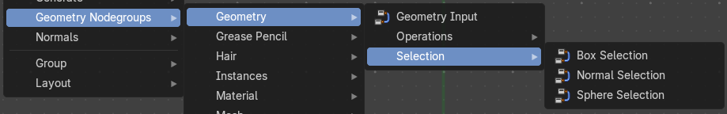
The nodes in this submenu are node groups. They use the regular single nodes under the hood.
It is virtually impossible to document these nodes in detail. So we will just list them.
When you double click the header, then you will enter the first level of the group. When you then press tab, or click again at the header, then you will reach the single nodes.




To leave the group you can use the breadcrumb up left in the header. These breadcrumbs are clickable. Or the Parent Node Tree button up right in the header.

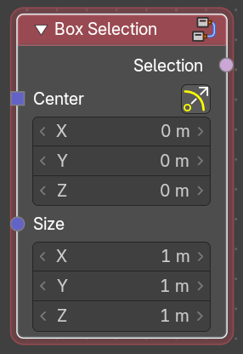
Box Selection
Box select geometry.

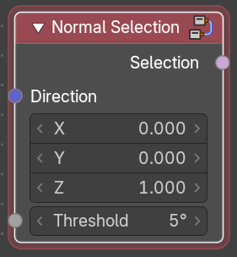
Normal Selection
Select geometry by the normals direction.

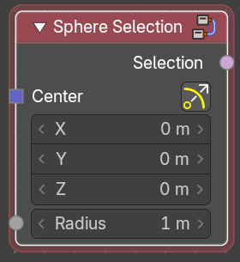
Sphere Selection
Select geometry by a sphere shape.

